Fax to 0141 211 4464
Insert patient sticky label here

Referring Consultant details:

Name ………………………………………
Hospital ………………………………………
Ward ………………………………………
Ward Telephone number ………………………
Hospital telephone number………………………

GP details (Or affix label)

Name ………………………...
Address………………………
……………………………….
Postcode .…………………….
Phone number ……………….

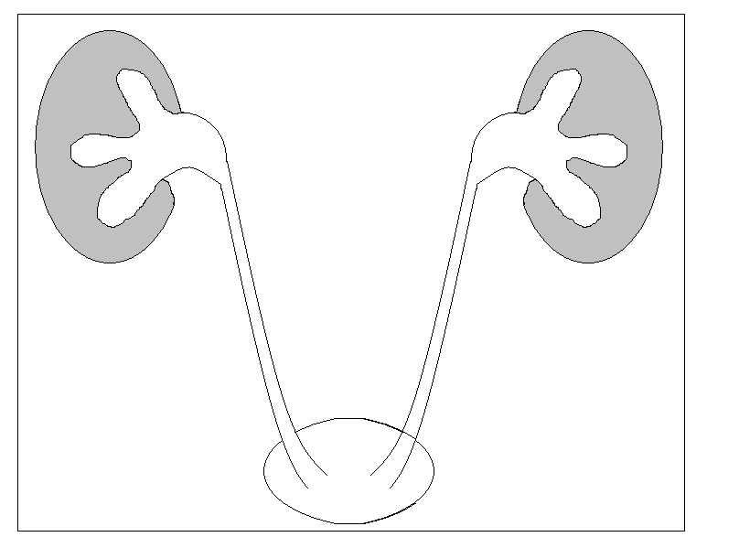
Stone details: Please circle where appropriate
Previous stone treatment:
URS (Yes or No)
PCNL (Yes or No)
Ureteric stent (Yes or No)
ESWL (Yes or No)

Stone details: Size in mm…………

Please mark stone position on diagram opposite:
Right Left
Patient details and comorbidity:

Previous MI or CVS disease Y N
Hypertension Y N
Diabetes Y N
Contrast Allergy or reaction Y N
Pacemaker or implantable defibrillator Y N
Anticoagulant / antiplatelet agent Y N
Any other (please state) ………………………...

Current Symptoms:
Pain (Yes or No)
Infection (Yes or No)
Previous investigations and dates:

CTKUB ……………………….
IVU ……………………………….
Isotope renogram ……………………

Please enclose all relevant X-rays with referral.

Doctor making referral ……………………… Page number …….………………………
Date of referral ………………………

